
Year 8 Mathematics
Mini-Test 2

Perimeter, Area and Volume

Resource Section: one A4 page of notes and calculator allowed

Name: ______________________
Time: 35 min Class: _____________ / 37 marks

Full working out must be shown to get full marks. Don’t forget to add appropriate units.
Attempt all the questions.

Part A – Perimeter 14 marks

Question 1: Convert the following units. [9 marks]

- 120 m = cm | - 4 km = m | - 5,450 mm = km
- 5 m² = km² | - 12,300,000 cm² = m² | - 4,000 mm² = cm²
- 687 mm³ = m³ | - 46 km³ = cm³ | - 5,000,000 cm³ = m³
Question 2: Find the perimeter of the following shapes. Make sure to include the correct units. [1,1,1,2 = 5 marks]

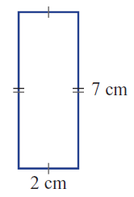 | 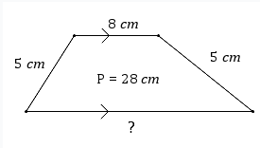
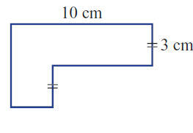 | 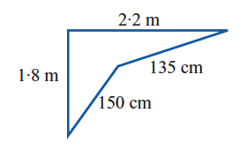
Part B - Area 9 marks

Question 3: Find the area of the following shapes. Make sure to include the correct units. [3 marks]

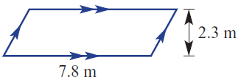 | 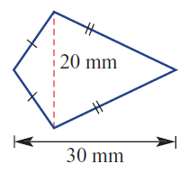
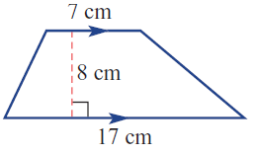

Question 4: Find the area of the composite shapes. Make sure to include the correct units. [6 marks]

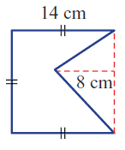 | 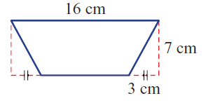
- (Find the area of the shaded section)

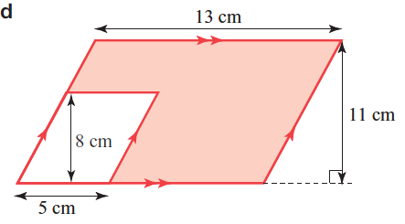

Part C – Volume 8 marks

Question 5: Find the volume of the following prisms. [2 marks]

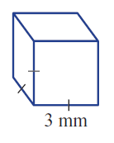 | 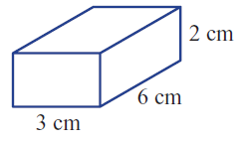

Question 6: Find the volume of the following prisms. Make sure to include the correct units. [4 marks]

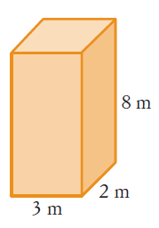  800 cm | 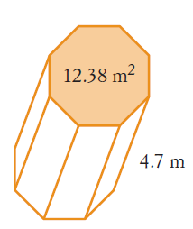
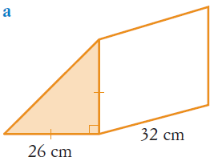

Question 7: Find the volume of the following prisms. Make sure to include the correct units. [2 marks]

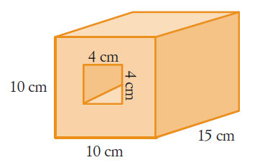

Part D – Worded Questions 6 marks

Question 9: A rectangular swimming pool is 6 m × 8.5 m. [1, 1, 1, 1, 2 = 6 marks]
- What is the area of the swimming pool?

The swimming pool is surrounded by a path that is 1 m wide.

- What are the dimensions of the swimming pool including the path?

- What is the area of the swimming pool including the path?

- If the pool is 1.5 m deep, find its:
  - volume, in m³

  - capacity, in L

